DBMS ASSIGNMENT

Abhishek Srivastava19BCE10071

1) The **Schema** and **Instance** are the essential terms related to databases. The major **difference between schema** and **instance** lies within their definition where **Schema** is the formal description of the structure of database whereas **Instance** is the set of information currently stored in a database at a specific time.

2)

* Data modeling is the process of developing data model for the data to be stored in a Database.
* Data Models ensure consistency in naming conventions, default values, semantics, security while ensuring quality of the data.
* Data Model structure helps to define the relational tables, primary and foreign keys and stored procedures.
* There are three types of conceptual, logical, and physical.

3)

DDL is Data Definition Language and is used to define the structures like schema, database, tables, constraints etc. Examples of DDL are create and alter statements. DML is Data Manipulation Language and is used to manipulate data. Examples of DML are insert, update and delete statements.

4)

A **2 Tier Architecture** in DBMS is a Database architecture where the presentation layer runs on a client (PC, Mobile, Tablet, etc.), and data is stored on a server called the second tier. Two tier architecture provides added security to the DBMS as it is not exposed to the end-user directly. It also provides direct and faster communication.

A **3 Tier Architecture** in DBMS is the most popular client server architecture in DBMS in which the development and maintenance of functional processes, logic, data access, data storage, and user interface is done independently as separate modules. Three Tier architecture contains a presentation layer, an application layer, and a database server.

5)

A Data Dictionary is a collection of names, definitions, and attributes about data elements that are being used or captured in a database, information system, or part of a research project. It describes the meanings and purposes of data elements within the context of a project, and provides guidance on interpretation, accepted meanings and representation. A Data Dictionary also provides metadata about data elements. The metadata included in a Data Dictionary can assist in defining the scope and characteristics of data elements, as well the rules for their usage and application.

6)

**Database** administrators (DBAs) use specialized software to store and organize data. The **role** may include capacity planning, installation, configuration, **database** design, migration, performance monitoring, security, troubleshooting, as well as backup and data recovery.

**7)**

**Entity Set** is a collection or a group of ‘entities’ sharing exactly the ‘same set of attributes’. All **entities** can be **distinctly identified** in an entity set.

8)

An entity set is a group of similar entities and these entities can have attributes. In terms of DBMS, an entity is a table or attribute of a table in database, so by showing relationship among tables and their attributes, ER diagram shows the complete logical structure of a database.

A set of relationships of similar type is called a relationship set. Like entities, a relationship too can have attributes. These attributes are called descriptive attributes.

9)Stored Attribute:When it is not possible to determine the value of an attribute using another attribute, then that attribute is called a stored attribute. For example, assume a table called Employee. There are attributes such as emp_id, name, department, location, etc. We cannot identify the values of these attributes using other attributes.

Derived Attribute; When it is possible to determine the value of an attribute using another attribute, then it is called a derived attribute. We can remove a derived attribute from the table, but we can also keep that attribute to improve understandability.

A stored attribute is an attribute that cannot be derived from other attributes while a derived attribute is an attribute that can be obtained using another stored attribute. Thus, this is the main difference between stored and derived attribute in DBMS.

10)Total Participation:

* It specifies that each entity in the entity set must compulsorily participate in at least one relationship instance in that relationship set.
* That is why, it is also called as **mandatory participation.**
* Total participation is represented using a double line between the entity set and relationship set.

Partial Participation:

* It specifies that each entity in the entity set may or may not participate in the relationship instance in that relationship set.
* That is why, it is also called as **optional participation.**
* Partial participation is represented using a single line between the entity set and relationship set.

11)  
Primary Key: Primary key uniquely identify a record in the table.Primary Key can't accept null values.By default, Primary key is clustered index and data in the database table is physically organized in the sequence of clustered index.We can have only one Primary key in a table.

Foreign key: Foreign key is a field in the table that is primary key in another table.Foreign key can accept multiple null value.Foreign key do not automatically create an index, clustered or non-clustered. You can manually create an index on foreign key.We can have more than one foreign key in a table.

12)

In one-to-many mapping, an entity in E1 is associated with at most one entity in E2, and an entity in E2 is associated with any number of entities in E1.

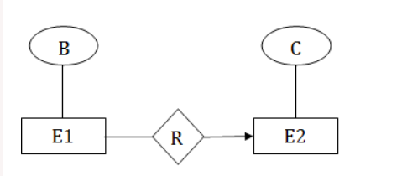

In many-to-many mapping, an entity in E1 is associated with any number of entities in E2, and an entity in E2 is associated with any number of entities in E1.

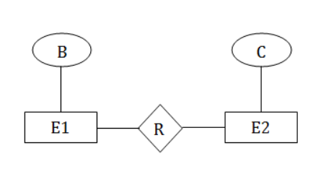

13)

**RELATIONAL ALGEBRA** is a widely used procedural query language. It collects instances of relations as input and gives occurrences of relations as output. It uses various operations to perform this action. SQL Relational algebra query operations are performed recursively on a relation. The output of these operations is a new relation, which might be formed from one or more input relations.

14) **Relation schema:** A set of attributes is called a relation schema (or relation scheme). A relation schema is also known as table schema (or table scheme). A relation schema can be thought of as the basic [information](https://ecomputernotes.com/fundamental/information-technology/what-do-you-mean-by-data-and-information) describing a table or relation. It is the logical definition of a table.

Database schema is a collection of meta-data. **Database schema** describes the structure and constraints of data representing in a particular domain.

15)

**Candidate Key:** The minimal set of attribute which can uniquely identify a tuple is known as candidate key. For Example, STUD_NO in STUDENT relation.

* The value of Candidate Key is unique and non-null for every tuple.
* There can be more than one candidate key in a relation. For Example, STUD_NO is candidate key for relation STUDENT.
* The candidate key can be simple (having only one attribute) or composite as well. For Example, {STUD_NO, COURSE_NO} is a composite candidate key for relation STUDENT_COURSE.
* No of candidate keys in a Relation are nC(floor(n/2)),for example if a Relation have 5 attribute i.e. R(A,B,C,D,E) then total no of candidate keys are 5C(floor(5/2))=10.